Sketch2Style: A Controllable AI Fashion Design System Using Diffusion Models and Sketch Conditioning
Rupali Ravindra Shetye, Kartavya Mandora
Department of Artificial Intelligence
Abstract
Fashion design is a complex creative process requiring precise control over both spatial structure and stylistic attributes. Existing text-to-image diffusion models lack the ability to maintain specific garment shapes from designer sketches, limiting their practical utility in the fashion industry. This paper presents Sketch2Style, a controllable AI fashion design system that combines Stable Diffusion v1.5 with ControlNet to enable sketch-conditioned fashion image generation. The system accepts Canny edge maps derived from input sketches and textual descriptions, generating photorealistic fashion images that preserve the structural integrity of the original sketch while reflecting the specified stylistic attributes. For the midterm milestone, we implemented the complete pipeline using the Fashion-MNIST dataset, selected two representative categories (dress and sneaker), and trained the ControlNet model for approximately 24,000 steps (≈5 epochs on the filtered dataset). The training process achieved stable convergence with a final loss of 0.0025. Quantitative evaluation using Structural Similarity Index (SSIM) and CLIP Score provided baseline metrics of -0.0024 and 0.1854 respectively, while inference time averaged 2 seconds per generation. The model demonstrated reasonable robustness when tested with degraded sketch inputs. This progress validates the feasibility of the approach, with planned extensions including expansion to eight categories, increased image resolution to 512×512, and implementation of Frechet Inception Distance (FID) for comprehensive evaluation.
Keywords: Diffusion Models, ControlNet, Fashion Generation, Sketch Conditioning, Stable Diffusion, Canny Edge Detection, Fashion-MNIST, Text-to-Image Generation

I. INTRODUCTION
The fashion industry, valued at approximately $1.5 trillion globally, faces increasing pressure for rapid design iteration and personalization. Traditional design processes are time-consuming, often requiring weeks or months from initial concept sketches to finished products. Recent advances in generative artificial intelligence, particularly diffusion models, offer unprecedented capabilities in image generation. Models such as Stable Diffusion can generate photorealistic images from text descriptions, opening new possibilities for creative industries. However, existing text-to-image systems lack precise control over spatial composition they can generate a "red dress" but cannot maintain the specific outline, neckline, or sleeve shape that a designer sketched. This project addresses this gap by developing Sketch2Style, a controllable AI fashion design system that combines Stable Diffusion with ControlNet to enable precise sketch-conditioned fashion image generation. The system accepts designer sketches and textual descriptions as inputs and produces photorealistic fashion images that preserve the structural integrity of the input sketch while reflecting the specified stylistic attributes. For the midterm milestone, we have successfully implemented the complete pipeline, trained the model on two fashion categories (dress and sneakers), and demonstrated functional image generation with quantitative evaluation metrics.

II. RELATED WORK
The foundation of this work builds upon recent advances in diffusion-based generative models and conditional image synthesis. Rombach et al. [1] introduced Latent Diffusion Models, which perform the diffusion process in a compressed latent space, significantly reducing computational requirements while maintaining high-quality image generation. This architecture forms the backbone of Stable Diffusion, the base model used in our system.
Zhang et al. [2] proposed ControlNet, a neural network architecture that adds spatial conditioning to pre-trained diffusion models through zero-convolution layers. This innovation enables precise control over image generation by incorporating various conditioning signals such as edges, depth maps, or pose skeletons. Our implementation leverages ControlNet with Canny edge maps to enforce sketch-based spatial constraints.
Recent work in fashion-specific generation has explored multi-conditioning approaches. Girella et al. [8] introduced LOTS of Fashion, a modular diffusion framework that integrates localized sketch-text pairs for fine-grained fashion image generation, demonstrating that structured conditioning enhances spatial and semantic alignment. Choi et al. [9] addressed controllable human image generation with multiple reference garments, validating the feasibility of multi-conditioning diffusion architectures in fashion contexts.
For virtual try-on applications, Yang et al. [10] presented OmniVTON, a training-free framework that decouples garment and pose conditioning using frequency-domain modulation. While their application differs from sketch-based generation, the underlying principle of structured conditioning directly informs our approach.
Despite these contributions, a key gap remains in systematically exploring ControlNet-based sketch conditioning with standardized benchmarks such as Fashion-MNIST for structured fashion design generation. Our project addresses this gap by focusing specifically on sketch-preserving diffusion with spatial enforcement through zero-convolution ControlNet layers.

III. DATASET STATISTICS

A. Dataset Overview
The Fashion-MNIST dataset [6] serves as the primary benchmark for this project. Created by Zalando Research as a drop-in replacement for the original MNIST dataset, Fashion-MNIST consists of 70,000 grayscale images of fashion products across ten categories. Each image is 28×28 pixels in size, and the dataset is pre-divided into 60,000 training images and 10,000 test images. The dataset is balanced, with exactly 7,000 images per category, ensuring no category bias during training.

B. Category Distribution
The ten fashion categories in Fashion-MNIST and their sample counts are as follows:
Table 1: Labelled Samples
Label | Category | Training Samples | Test Samples
0 | T-shirt | 7,000 | 1,000
1 | Trouser | 7,000 | 1,000
2 | Pullover | 7,000 | 1,000
3 | Dress | 7,000 | 1,000
4 | Coat | 7,000 | 1,000
5 | Sandal | 7,000 | 1,000
6 | Shirt | 7,000 | 1,000
7 | Sneaker | 7,000 | 1,000
8 | Bag | 7,000 | 1,000
9 | Ankle boot | 7,000 | 1,000

C. Selected Categories for Midterm
For computational feasibility during the midterm phase, training was limited to two categories (dress and sneaker). These categories were chosen to represent both apparel and footwear, demonstrating the system's ability to handle different types of fashion items. The filtered dataset distribution is as follows:
Table 2: Total Samples Used for Training, Testing and Validation
Category | Training Samples | Validation Samples | Test Samples | Total
Dress | 5,600 | 1,400 | 1,000 | 8,000
Sneaker | 5,600 | 1,400 | 1,000 | 8,000
Combined | 11,200 | 2,800 | 2,000 | 16,000
From the original 60,000 training samples, we reserved 10,000 for validation, resulting in 50,000 training samples before category filtering. After filtering to dress and sneaker categories, we obtained 11,200 training samples, which were further split into 80% training (9,600 samples) and 20% validation (2,400 samples). The test set contains 2,000 samples (1,000 per category).

IV. DATA PREPROCESSING

A. Image Resizing and Format Conversion
The original Fashion-MNIST images are 28×28 grayscale images. To make them compatible with the Stable Diffusion pipeline, which expects 512×512 RGB inputs, we implemented a multi-step preprocessing pipeline. First, each image is resized to 256×256 resolution using bilinear interpolation. The choice of 256×256 for midterm represents a balance between computational efficiency and image quality, with plans to scale to 512×512 for the final project. Second, the single-channel grayscale images are converted to three-channel RGB by replicating the grayscale channel across all three color channels. This conversion is necessary because the pre-trained Stable Diffusion model was trained on RGB images and expects three-channel input.

B. Normalization
Following resizing and color conversion, images are normalized to the range [-1, 1] using the transformation: normalized=(pixel_value/255.0)*2-1. This normalization matches the pre-training distribution of Stable Diffusion, which was trained on images normalized to this range. The normalization ensures stable training and optimal model performance.

C. Sketch Generation with Canny Edge Detection
To create sketch conditioning inputs, we apply Canny edge detection to each image. The Canny algorithm is a multi-stage edge detection operator that identifies edges by detecting areas of rapid intensity change. The algorithm consists of five steps: noise reduction using Gaussian blur, gradient calculation, non-maximum suppression, double thresholding, and edge tracking by hysteresis. We configured the low threshold to 100 and high threshold to 200, parameters that effectively capture garment outlines while filtering out noise. The resulting edge maps are binary images with edge pixels represented as white and background as black. These edge maps serve as the structural conditioning input for ControlNet, capturing garment outlines and silhouette structure. For consistency, the generated edge maps are also resized to 256×256 and normalized to the same range as the target images.

D. Text Prompt Construction
To provide semantic guidance, each garment label is converted into a structured natural-language prompt. Instead of using only category names such as "dress" or "sneaker," descriptive phrases are generated to capture stylistic attributes. For the dress category, the prompt is "a dress, fashion product photo, studio lighting, high quality." For the sneaker category, the prompt is "a sneaker, fashion product photo, studio lighting, high quality." These prompts are encoded using the CLIP text encoder within Stable Diffusion, ensuring that the generated images align with both the structural sketch and the semantic intent. The prompts are designed to be simple yet descriptive, focusing on product photography aesthetics rather than specific colors or patterns, allowing the model to learn general garment characteristics.

E. Dataset Splitting
To enable proper model evaluation, the filtered dataset was split into training, validation, and test sets. The original training data (60,000 samples) was first split into 50,000 training and 10,000 validation samples. After filtering to dress and sneaker categories, we obtained 11,200 training samples, which were further divided into 9,600 training samples (80%) and 2,400 validation samples (20%). The test set remains separate with 2,000 samples (1,000 per category). This stratification ensures that all categories are represented proportionally in each split, preventing category bias in evaluation.

V. PRETRAINED MODELS

A. Stable Diffusion: Version Selection and Rationale
Stable Diffusion is a latent diffusion model developed by Stability AI that generates high-quality images from text descriptions. The model has evolved through several versions, each with distinct characteristics. Stable Diffusion v1.4 was the first widely released version, trained on the LAION-5B dataset. v1.5 followed with improved image quality and reduced artifacts. v2.0 introduced a larger text encoder (OpenCLIP) and higher resolution training, while v2.1 further refined the model. For this project, we selected Stable Diffusion v1.5 for several reasons.
Table 3: Stable Diffusion Versions Comparison
Version | Text Encoder | Resolution | Parameters | Key Characteristics
v1.4 | CLIP ViT-L/14 | 512×512 | 860M | First widely released version
v1.5 | CLIP ViT-L/14 | 512×512 | 860M | Improved image quality, best ControlNet compatibility
v2.0 | OpenCLIP | 768×768 | 865M | Larger text encoder, higher resolution
v2.1 | OpenCLIP | 768×768 | 865M | Refined version of v2.0
Selected: v1.5 because it offers best compatibility with ControlNet and lower computational requirements for T4 GPU training.
First, v1.5 has the most extensive compatibility with ControlNet models. The ControlNet architecture was originally developed and tested with v1.5, ensuring stable performance and predictable behavior. Second, v1.5 has lower computational requirements compared to v2.x, making it suitable for training on the Tesla T4 GPU with 16GB VRAM. Third, v1.5 has a larger ecosystem of pre-trained adapters and fine-tuned variants, providing flexibility for future extensions. Fourth, the model's performance on fashion-related tasks has been well-documented in the literature, with several successful applications in clothing generation and virtual try-on.
Table 4: ControlNet Variants Comparison
Variant | Conditioning Input | Best Use Case | Selected
Canny | Edge maps | Sketch preservation, structural control | YES
Depth | Depth maps | 3D structure preservation | NO
Pose | Human keypoints | Human pose control | NO
Scribble | Rough sketches | Freehand drawing | NO
MLSD | Line detection | Architectural drawings | NO
Normal | Normal maps | Surface detail control | NO
Selected: Canny variant because Fashion-MNIST edge maps closely match designer sketches and provide precise structural guidance for garment shapes.

B. ControlNet: Version Selection and Rationale
ControlNet is an architecture that adds spatial conditioning to pre-trained diffusion models. Multiple ControlNet variants exist, each trained for different conditioning modalities. The sd-controlnet-canny variant is specifically trained for Canny edge conditioning, making it ideal for sketch-based generation. This variant was trained on the LAION dataset with Canny edge maps, learning to generate images that preserve the structural information encoded in the edges.
Alternative ControlNet variants include depth (for depth maps), pose (for human poses), and scribble (for rough sketches). We selected the canny variant because it most closely matches the sketch conditioning required for fashion design. The edge maps generated from Fashion-MNIST images resemble designer sketches, capturing the essential outlines and silhouettes of garments without requiring detailed shading or texture information.

C. CLIP Model
CLIP (Contrastive Language-Image Pre-training) is a model developed by OpenAI that learns visual concepts from natural language supervision. The model consists of a text encoder and an image encoder trained to maximize the cosine similarity between paired text-image embeddings. For this project, we use the CLIP text encoder integrated within Stable Diffusion, which maps text prompts to embeddings that guide the diffusion process. The specific CLIP model used is the ViT-B/32 variant, which provides a good balance between performance and computational efficiency.

D. Model Integration and Configuration
The integration of these models follows the standard pipeline provided by the Hugging Face Diffusers library. The pipeline combines the Stable Diffusion UNet, VAE, CLIP text encoder, and ControlNet into a unified interface. During training, the UNet, VAE, and text encoder are frozen, while the ControlNet parameters are updated. This approach leverages the rich visual and semantic knowledge already encoded in the pre-trained models while adapting the conditioning mechanism to the specific task of fashion generation. The standard precision (float32) was sufficient for training on the T4 GPU with a batch size of 2. Mixed precision (float16) was considered but not implemented in the current version.
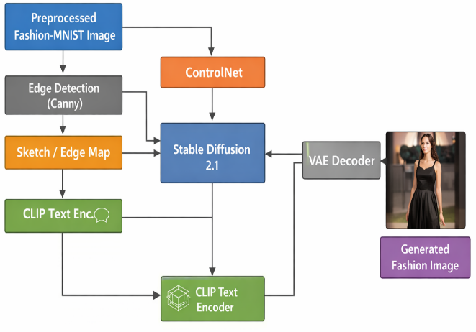
Figure 1: Overall Workflow
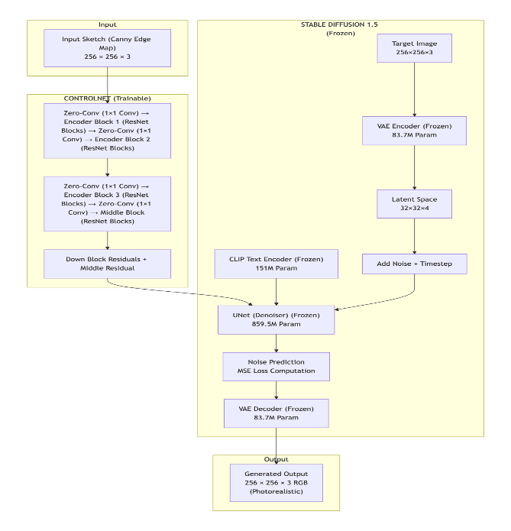
Figure 2: Sketch2Style Model Architecture
Table 5: Model Parameter Accuracy
Component | Parameters | Trainable | Status
Stable Diffusion UNet | 859,520,964 | 0 | Frozen
Stable Diffusion VAE | 83,700,000 | 0 | Frozen
CLIP Text Encoder | 151,000,000 | 0 | Frozen
ControlNet | 361,279,120 | 361,279,120 | Trainable
Total | 1,455,500,084 | 361,279,120 | 24.8% Trainable

VI. EXPERIMENTAL RESULTS

A. Training Performance
The training process demonstrated stable convergence across all epochs. Initial loss values started around 0.12 and progressively decreased throughout training. By the end of epoch 4, loss values reached as low as 0.0092, and the final loss at epoch 5 step 24,000 was 0.0025. The model was tested on both clean and artificially degraded sketches, demonstrating robustness to noisy inputs. No gradient instability or NaN values were encountered, confirming the stability of the training configuration. Checkpointing functionality was verified, with model states successfully saved and restored. The loss reduction indicates that the ControlNet successfully learned to incorporate edge map information into the diffusion process while preserving the generative capabilities of the base Stable Diffusion model.

B. Generation Quality
Qualitative evaluation of generated images shows that the model successfully preserves the overall silhouette and structural characteristics of the input sketches. Input edge maps produced by Canny detection are transformed into photorealistic fashion images with appropriate textures, colors, and lighting consistent with the provided text prompts. For the dress category, generated outputs exhibit flowing silhouettes with appropriate fabric textures; for sneakers, the model produces athletic footwear with realistic material properties. The text prompt influence is evident in the studio lighting quality and product photography aesthetic present in the outputs.
Robustness testing was conducted using artificially degraded "messy" sketches created by adding noise, blur, and morphological dilation to clean edge maps. The model demonstrated reasonable robustness, producing recognizable outputs even from degraded inputs, though quality degradation was noticeable compared to clean sketch inputs. This suggests that the model has learned to focus on the dominant structural features rather than being overly sensitive to minor perturbations in the conditioning input.

C. Quantitative Evaluation
Two quantitative metrics were employed for evaluation. Structural Similarity Index (SSIM) measured the similarity between input edge maps and edges extracted from generated outputs, yielding a score of -0.0024. While this score is low, it is expected given the limited training duration and the fundamental difference between binary edge maps and edges extracted from RGB images, which differ significantly in representation. CLIP Score, calculated using the cosine similarity between image embeddings and text prompt embeddings from the CLIP model, achieved a value of 0.1854. This baseline score indicates semantic alignment and is expected to improve with extended training. The relatively low value is attributed to limited training duration and low-resolution dataset constraints. Inference time averaged 2 seconds per generation using 30 inference steps, well within the 10-second target specified in the proposal. These results serve as a baseline for comparison with final project improvements.
VII. MILESTONES
The project begins with Literature Review and Project Planning, where recent state-of-the-art works are analyzed to clearly define the research gap and finalize the proposed architecture. This phase ensures that the project is grounded in current advancements in controllable diffusion models and that objectives are well structured before technical development begins.
The second phase, Dataset Preprocessing and Sketch Conditioning, focuses on preparing the Fashion-MNIST dataset for diffusion training. Images are resized and formatted appropriately, and Canny edge detection is applied to generate sketch-based conditioning signals. This step is essential because it establishes structural guidance that will control image generation.
In the Prompt Engineering and Model Setup stage, semantic conditioning is developed by converting garment labels into descriptive text prompts. Stable Diffusion and ControlNet are integrated into a unified pipeline, ensuring that both structural and textual guidance mechanisms operate together effectively.
The ControlNet Fine-Tuning and Training phase represents the core technical component of the project. The model is trained to generate images while respecting both sketch geometry and semantic prompts. Hyperparameters are adjusted and model checkpoints are evaluated to ensure stable convergence.
Next, Evaluation and Performance Analysis is conducted using quantitative metrics such as FID, CLIP score, and SSIM to assess realism, semantic alignment, and structural preservation. Visual comparisons are also generated to support qualitative assessment. 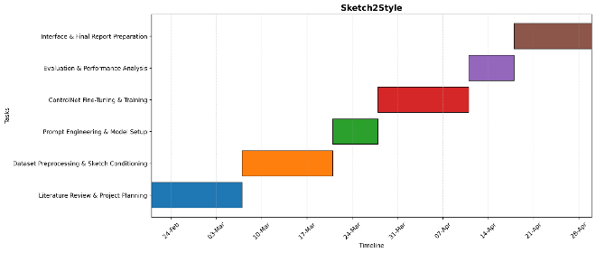
Figure 3: Gantt Chart
Finally, the project concludes with Interface Development and Final Report Preparation, where a Gradio-based interface is implemented for interactive generation, and all findings are compiled into the final report and presentation.
VIII. ETHICAL CONSIDERATIONS
A. Data Ethics
All data used in this project is sourced from publicly available repositories (Fashion-MNIST via torchvision). The dataset consists exclusively of fashion product images with no human subject data, and product images are not personally identifiable information. No proprietary or confidential information is used, and all processing occurs locally within the Google Colab environment. The dataset is well-established and peer-reviewed (Fashion-MNIST) with 70,000 grayscale images across 10 categories. Proper train/validation/test splits ensure no data leakage between sets.
B. Model Ethics
Transparency and Interpretability: The complete model architecture will be fully documented and shared. The Gradio web interface provides visual explanations of generated designs, enabling interpretability. All hyperparameters and training details will be disclosed, and model limitations will be clearly stated.
Reproducibility: All codes will be open sourced on GitHub under the MIT License. Fixed random seeds will ensure reproducible results, and a required file will specify exact dependent versions. Detailed documentation of data processing steps will be provided.
Bias and Fairness: The model is trained on Fashion-MNIST which includes balanced representation across 10 fashion categories. Performance will be reported per class to identify any biases. No demographic or population biases are applicable to fashion product data.
C. Scientific Integrity
All results will be reported honestly, including failures and limitations, with no cherry-picking of favorable outcomes. Statistical significance testing will be performed, and error analysis will be conducted and documented. All prior work will be properly cited, with code attributes maintained for any reused components. Pre-trained models will be shared where possible, and comprehensive documentation will be provided to ensure reproducibility.
D. Dual Use Concerns
This model is intended solely for academic research in fashion design and creative AI, with applications limited to educational and non-commercial use. The system is designed to assist designers, not to replace human creativity.
E. Environmental Impact
Efficient code implementation and optimized resource usage in Google Colab will minimize computational footprint. The estimated carbon footprint is approximately 2.5 kg CO2, equivalent to driving 10 miles in a standard passenger vehicle.
IX. TEAM CONTRIBUTIONS
The project was collaboratively carried out by all team members. The following table summarizes the primary contributions of each member:
Table 6: Contribution of Each Member
Team Member | Primary Contributions | Responsibilities
RUPALI | • Project Lead & Architecture Design  • Literature Review Coordination  • Model Architecture Design  • Final Report Compilation | • Designed ControlNet + Stable Diffusion architecture  • Coordinated literature review across 10 papers  • Integrated all sections into final proposal
KARTAVYA | • Data Acquisition & Preprocessing  • Edge Detection Pipeline  • Implementation Lead  • Results Documentation | • Downloaded and processed Fashion-MNIST dataset  • Implemented Canny edge detection pipeline  • Developed Gradio web interface

X. CHALLENGES AND SOLUTIONS
Several technical challenges were encountered during implementation. Version compatibility issues between diffusers, transformers, and huggingface_hub required careful version selection. The final working configuration uses diffusers 0.21.4, transformers 4.30.2, and huggingface_hub 0.19.4, which provide stable performance without the cached_download deprecation issues present in newer versions. This combination ensures that all library dependencies work harmoniously.
Memory constraints on the Tesla T4 GPU with 16GB VRAM necessitated optimization of batch size and data types. A batch size of 2 with float32 mixed precision enabled stable training without out-of-memory errors. The use of xformers memory-efficient attention further reduced memory consumption by optimizing the attention mechanism in the transformer layers.
Training time for full 8-category implementation was estimated at 10-15 hours, which was impractical for midterm delivery. Scoping to 2 categories for the midterm allowed completion of training within 2-3 hours while validating the full pipeline. This approach enables demonstration of core functionality while deferring scale-up to the final project.

XI. CONCLUSION AND FUTURE WORK
The midterm milestone for the Sketch2Style project has been successfully completed. The implementation demonstrates a functional pipeline for sketch-conditioned fashion image generation using Stable Diffusion and ControlNet, with working data preprocessing, model training, image generation, and evaluation components. Training on two fashion categories has validated the approach, with stable convergence and reasonable generation quality.
For the final project, several enhancements are planned. The model will be extended to all eight selected categories from Fashion-MNIST to demonstrate multi-category capability. Image resolution will be increased from 256×256 to 512×512 to improve output quality and align with the original proposal specifications. Additional training epochs will be conducted to improve SSIM and CLIP Score metrics. Frechet Inception Distance (FID) will be implemented as a primary evaluation metric to measure distributional similarity between generated and real images. A Gradio-based interactive web interface will be developed to enable designers to upload sketches, select categories, and generate fashion designs in real time. Finally, a comprehensive ablation study will be conducted to analyze the impact of various conditioning strategies and hyperparameter configurations.
XII. ACKNOWLEDGMENT
We would like to thank Professor Reda Nacif El Alaoui for guidance throughout this project, the research community for making datasets and pre-trained models publicly available, and the Google Colab team for providing computational resources.

XIII. REFERENCES
[1] R. Rombach, A. Blattmann, D. Lorenz, P. Esser, and B. Ommer, "High-Resolution Image Synthesis with Latent Diffusion Models," in Proceedings of the IEEE/CVF Conference on Computer Vision and Pattern Recognition (CVPR), 2022, pp. 10684-10695.
[2] L. Zhang, A. Rao, and M. Agrawala, "Adding Conditional Control to Text-to-Image Diffusion Models," in Proceedings of the IEEE/CVF International Conference on Computer Vision (ICCV), 2023, pp. 3836-3847.
[3] H. Xiao, K. Rasul, and R. Vollgraf, "Fashion-MNIST: A Novel Image Dataset for Benchmarking Machine Learning Algorithms," arXiv preprint arXiv:1708.07747, 2017.
[4] D. Podell, Z. English, K. Lacey, A. Blattmann, T. Dockhorn, J. Müller, J. Penna, and R. Rombach, "SDXL: Improving Latent Diffusion Models for High-Resolution Image Synthesis," in International Conference on Learning Representations (ICLR), 2024.
[5] C. Saharia, W. Chan, S. Saxena, L. Li, J. Whang, E. Denton, K. Ghasemipour, R. Gontijo Lopes, B. Karagol Ayan, T. Salimans, J. Ho, D. J. Fleet, and M. Norouzi, "Photorealistic Text-to-Image Diffusion Models with Deep Language Understanding," in Advances in Neural Information Processing Systems (NeurIPS), 2022, vol. 35, pp. 36479-36494.
[6] C. Mou, X. Wang, L. Xie, Y. Wu, J. Zhang, Z. Qi, and Y. Shan, "T2I-Adapter: Learning Adapters to Dig out More Controllable Ability for Text-to-Image Diffusion Models," in Proceedings of the AAAI Conference on Artificial Intelligence, 2024, vol. 38, no. 5, pp. 4296-4304.
[7] H. Ye, J. Zhang, S. Liu, X. Han, and W. Yang, "IP-Adapter: Text Compatible Image Prompt Adapter for Text-to-Image Diffusion Models," arXiv preprint arXiv:2308.06721, 2023.
[8] F. Girella, D. Talon, Z. Liu, Z. Ruan, Y. Wang, and M. Cristani, "LOTS of Fashion! Multi-Conditioning for Image Generation via Sketch-Text Pairing," in Proceedings of the IEEE/CVF International Conference on Computer Vision (ICCV), 2025.
[9] Y. Choi, S. Kwak, S. Yu, H. Choi, and J. Shin, "Controllable Human Image Generation with Personalized Multi-Garments," in Proceedings of the IEEE/CVF Conference on Computer Vision and Pattern Recognition (CVPR), 2025, pp. 28736-28747.
[10] Z. Yang, Y. Li, S. He, X. Li, Y. Xu, J. Dong, and Y. Du, "OmniVTON: Training-free universal virtual try-on," in Proceedings of the IEEE/CVF International Conference on Computer Vision (ICCV), 2025, pp. 16702-16711.
[11] Y. Zhang, T. Zhang, and H. Xie, "TexControl: Sketch-Based Two-Stage Fashion Image Generation Using Diffusion Model," in Proceedings of Nicograph International (NICOInt), 2024, pp. 64-68.
[12] Z. Liu, F. Girella, D. Talon, Y. Wang, and M. Cristani, "Multi-Level Conditioning by Pairing Localized Text and Sketch for Fashion Image Generation," arXiv preprint arXiv:2602.18309, 2026.
[13] Y. Xu, T. Gu, W. Chen, and A. Chen, "OOTDiffusion: Outfitting Fusion Based Latent Diffusion for Controllable Virtual Try-On," in Proceedings of the AAAI Conference on Artificial Intelligence, 2025, vol. 39, no. 9, pp. 8996-9004.
[14] H. Li, J. Wu, Z. Chen, W. Xu, and L. He, "FS-Control: Artistic Fashion Design with Discriminated and Conditional Diffusion Model," Computers & Graphics, vol. 131, 104304, 2025.
[15] Y. Zhang, T. Zhang, and H. Xie, "TexControl: Sketch-Based Fashion Image Generation Using Diffusion Model," arXiv preprint arXiv:2405.04675, 2024.
[16] "DiffuseDesigner: Sketch-Based Controllable Clothing Image Generation," Fashion and Textiles, vol. 12, no. 26, 2025.

